**Experiment # 6**

Verification of Kirchhoff’s Voltage Law (KVL) using Breadboard

**Objective:**

To verify Kirchhoff’s Voltage Law (KVL) on Breadboard and know relationship between varying resistors and applied voltage.

**Apparatus:**

1. DMM
2. Resistors
3. DC power supply

**Procedure:**

|  |  |  |  |  |  |  |  |  |
| --- | --- | --- | --- | --- | --- | --- | --- | --- |
| **S.no** | **Vs**  **(actual)**  **(V)** | **R1**  **(Measured)**  **(Ω)** | **R2**  **(Measured)**  **(Ω)** | **V1**  **(Measured)**  **(V)** | **V2**  **(Measured)**  **(V)** | **V1+V**  **2**  **(V)** | **Erro r** | **Percentage**  **Error**  **(%)** |
| 1. | 5 |  |  |  |  |  |  |  |
| 2. | 10 |  |  |  |  |  |  |  |

1. Design the following circuit on breadboard

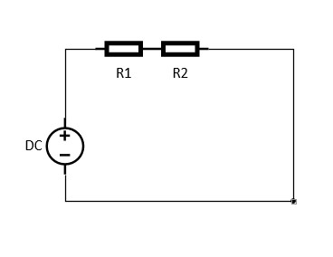

Figure 1 Circuit diagram

1. Using DMM find resistance of the resistors and note down in the table.
2. Find voltage of DC source and voltage drop on each resistor and note down in the table.
3. Add the voltage drops and compare with the source voltage by finding the percentage error.

**Observation:**

|  |  |  |  |  |  |  |  |  |
| --- | --- | --- | --- | --- | --- | --- | --- | --- |
| 3. | 15 |  |  |  |  |  |  |  |
| 4. | 20 |  |  |  |  |  |  |  |
| 5. | 30 |  |  |  |  |  |  |  |